**Celebrity Image Recognition using Machine Learning and Deep Learning**

(CSE V SEMESTER MINI PROJECT)

2022-2023



**Submitted to: Submitted by:**

**Dr. Pankaj Jha John Alexander**

**(CC-CSE-E-V-Sem) ROLL NO.-2018400(31)**

**CSE-E-V-Sem**

**Session: 2021-2022**

**DEPARTMENT OF COMPUTER SCIENCE AND ENGINEERING**

**TABLE OF CONTENTS**

**1. INTRODUCTION**

* 1. Object Recognition
  2. Face Detection and Classification
  3. Machine Learning
  4. Deep Learning
  5. Abstract

**2. METHODOLOGY**

1. Getting the correct dataset.
2. Data cleaning
3. Data Organisation
4. Feature Extraction
5. Developing the training and testing data
6. Training the model using GridSearchCV
7. Testing the model
8. Designing the front end
9. API Creation
10. Designing a functional website
11. Deployment

**3. FURTHER ENHANCEMENTS**

**4. REFERENCE**

**INTRODUCTION**

* 1. **Object Recognition**

Object Recognition refers to recognising the image that is uploaded or shown and based on the backend algorithm the machine predicts who or what the object(s) in the picture is.

This project utilises the image recognition concept to recognise famous celebrities in the given image which is uploaded to the model.

* 1. **Face Detection and Classification**

Face Detection is one of the key components of celebrity classification and recognition. It is implemented through computer vision which is one of the fields of AI (Artificial Intelligence). Computer vision in AI is dedicated to the development of automated systems that can interpret visual data (such as photographs or motion pictures) in the same manner as people do.

The idea behind computer vision is to instruct computers to interpret and comprehend images on a pixel-by-pixel basis. This is the foundation of the computer vision field. Regarding the technical side of things, computers will seek to extract visual data, manage it, and analyse the outcomes using sophisticated software programs.

* 1. **Machine Learning**

Machine learning is an application of AI that enables systems to learn and improve from experience without being explicitly programmed. Machine learning focuses on developing computer programs that can access data and use it to learn for themselves.

* 1. **Deep Learning**

Deep Learning is a subfield of machine learning concerned with algorithms inspired by the structure and function of the brain called artificial neural networks.

Neural networks are layers of nodes, much like the human brain is made up of neurons. Nodes within individual layers are connected to adjacent layers. The network is said to be deeper based on the number of layers it has. A single neuron in the human brain receives thousands of signals from other neurons. In an artificial neural network, signals travel between nodes and assign corresponding weights. A heavier weighted node will exert more effect on the next layer of nodes. The final layer compiles the weighted inputs to produce an output.

* 1. **Abstract**

There are multiple ways to go about face detection and classification. This project will incorporate HaarCascade Classifier for Machine Learning Part of the Project and for Deep Learning Part, ANN(Artificial Neural Network).

Object Detection using Haar feature-based cascade classifiers is an effective object detection method proposed by Paul Viola and Michael Jones in their paper, "Rapid Object Detection using a Boosted Cascade of Simple Features" in 2001. It is a machine learning based approach where a cascade function is trained from a lot of positive and negative images. It is then used to detect objects in other images.

A pre-trained frontal face and eye model will be used to detect face and consequently match with the database of image for recognition.

The term "Artificial Neural Network" is derived from Biological neural networks that develop the structure of a human brain. Similar to the human brain that has neurons interconnected to one another, artificial neural networks also have neurons that are interconnected to one another in various layers of the networks. These neurons are known as nodes.

The UI will be a drag and drop interface that will allow user to drag and drop an image and the application will recognize the person in the image.

This will be a comparative study of Deep Learning Approach and Machine Learning approach for image classification and recognition which will be based on Algorithm Accuracy, Error, Algorithm Optimization etc.

**METHODOLOGY**

Steps to be followed in this project :

1. Getting the correct dataset.
2. Data cleaning
3. Data Organisation
4. Feature Extraction
5. Developing the training and testing data
6. Training the model using GridSearchCV
7. Testing the model
8. Designing the front end
9. API Creation
10. Designing a functional website
11. Deployment

**WEEK 1 :**

1. **Data Collection**

The data is in the form of images which are collected on the basis of different celebrities.

The image dataset contains the images of 5 different celebrities namely :-

1. Lionel Messi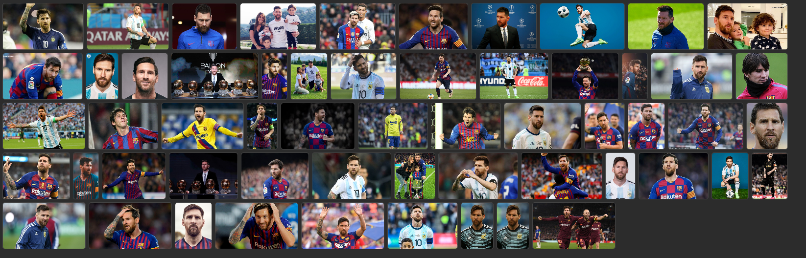
2. Maria Sharapova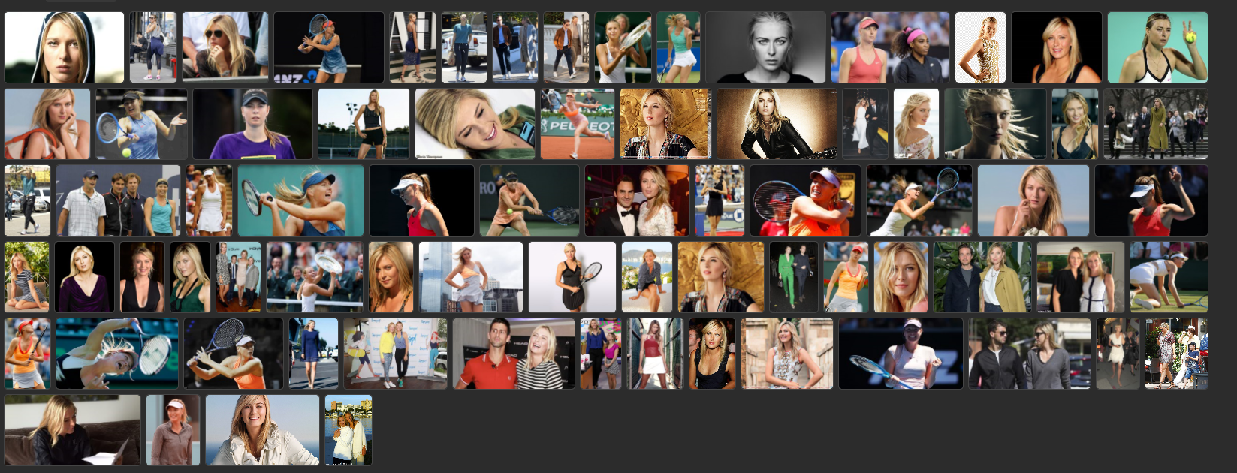
3. Serena Williams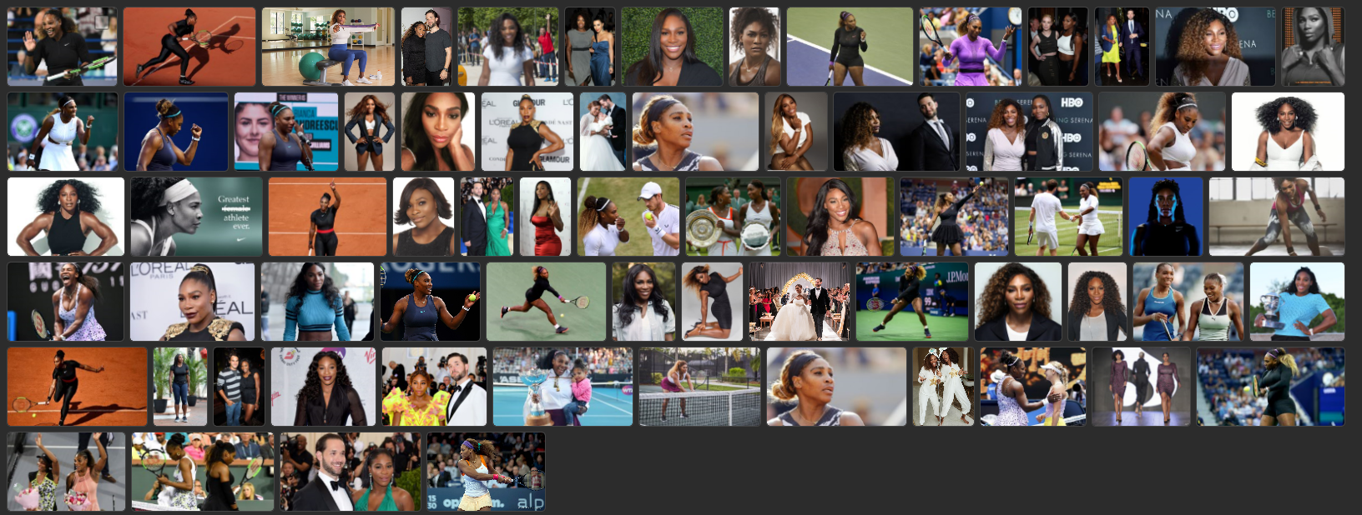
4. Roger Federer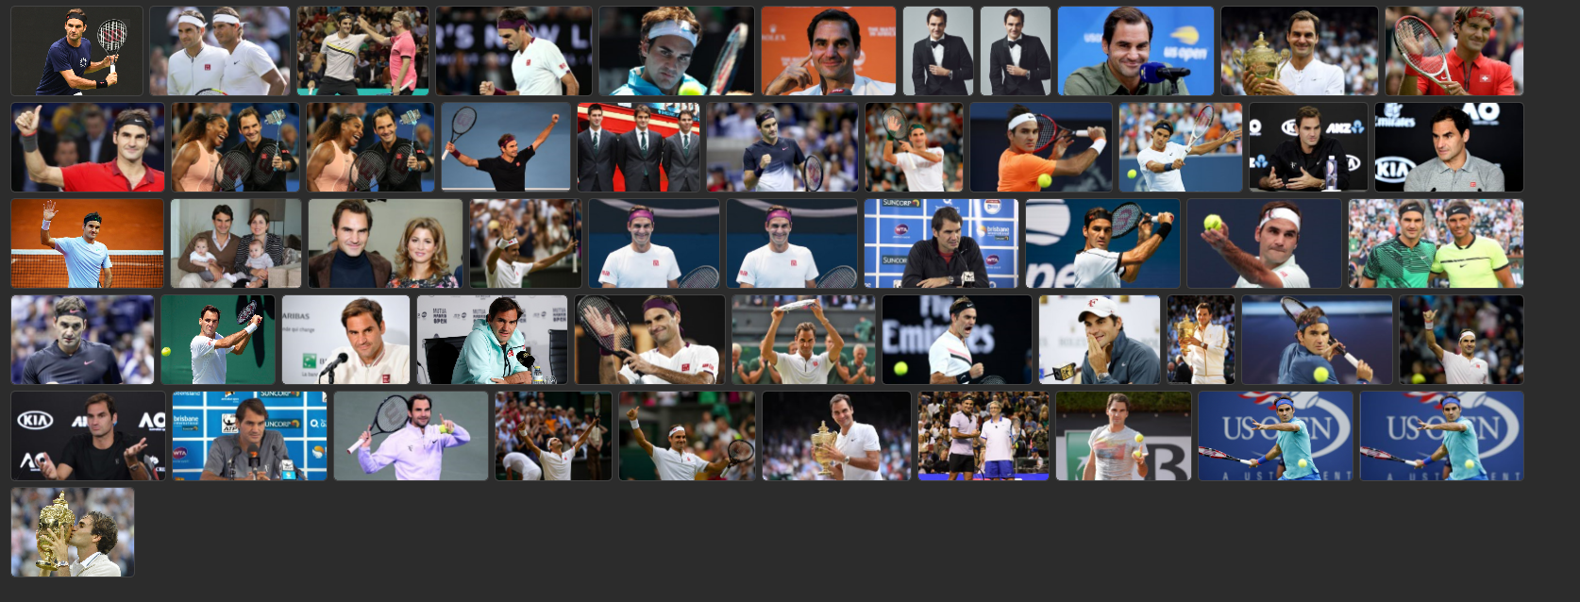
5. Virat Kohli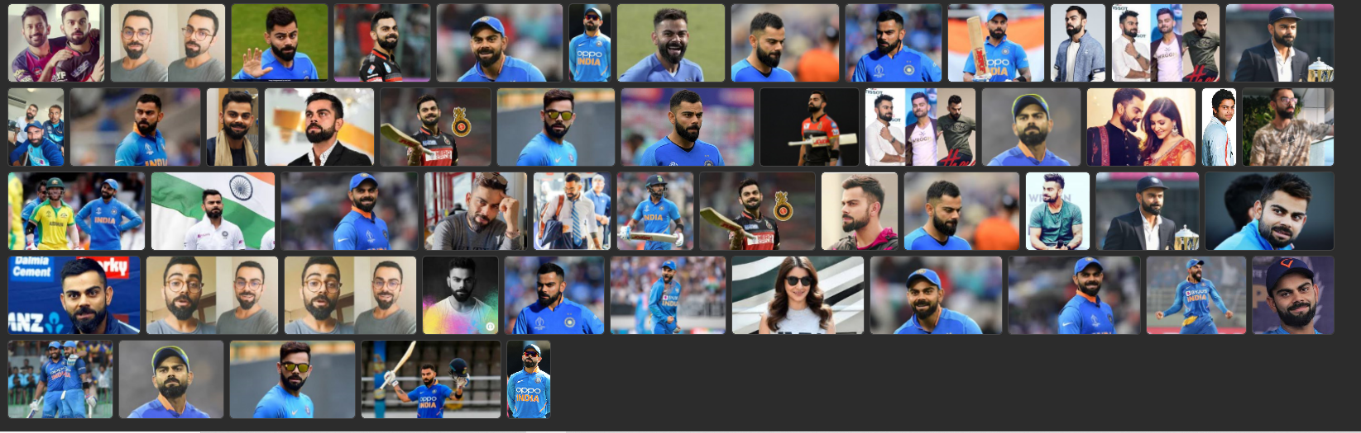

These images are of various sizes, forms(blurred, clear, partially visible etc.) and to further use it in the Model Building, it needs to be cleaned.

1. **Data Cleaning**

The idea is to detect the face having atleast 2 eyes for it to be considered to be a valid face for classification training.

Using Haar Cascade, valid faces are extracted from their raw images.



Cropping the images and forming a cropped image dataset from raw images

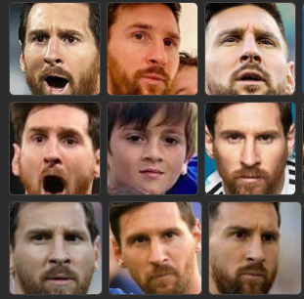 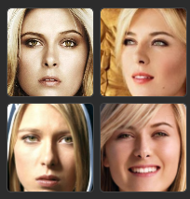

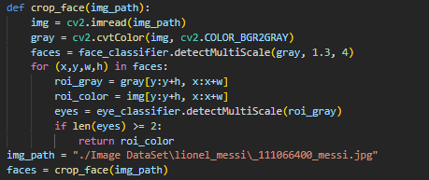

Similarly for all Celebrity Images, the face is extracted and stored. The dataset may contain the faces of people other than the required celebrity and those images will need to be manually removed. This will give us a more accurate result and model will be optimised.

1. **Data Organisation**

The cropped images are stored in a separate folder thorough python code using os library.

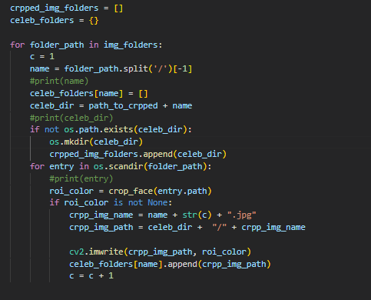

**WEEK 2 :**

1. **Feature Extraction**

The images are then converted using wavelet transformation for extracting the facial features of the cropped celebrity images. 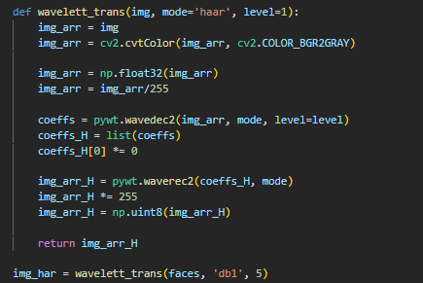

The Transformed Image :

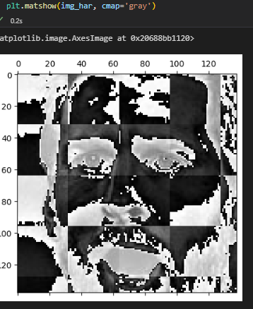

As clearly seen in the Transformed Image, the facial features i.e. eyes, noes, mouth etc. are now distinctively dominant.

1. **Developing the training and testing data**

The image matrix will now be stacked vertically for optimising the dataset content and divided into X and Y data for input to the model and classification.

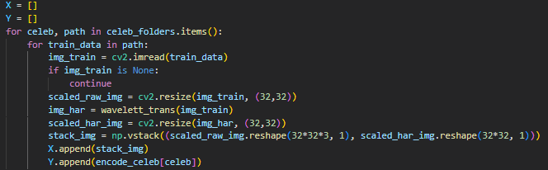

The images are resized to a normalised size (32 X 32) and appended to X for input dataset and the Class i.e. Celebrity names encoded from [0 – 4] in Y dataset.

1. **Training the model using GridSearchCV**

The X and Y data is now fed into different algorithms for the model to be trained.

The most popular Machine Learning Algorithms for classification are :-

1. Random Forest Classifier
2. Logistic Regression
3. Support Vector Classifier

GridSearchCV is used to optimally tune the hyperparameters and find the best algorithm suited for the project. The parameter declaration are as follows:

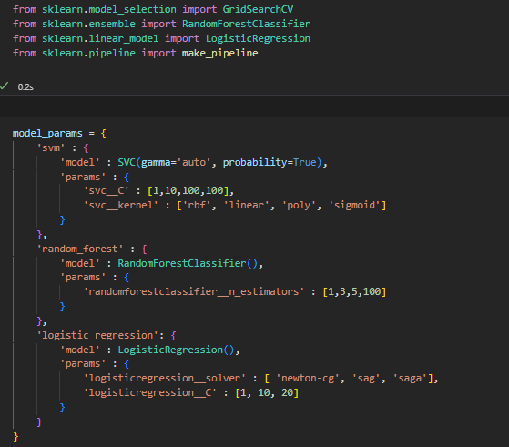

The concept of pipelining is used to incorporate the scaling of dataset and automate the HyperParameter Optimization.

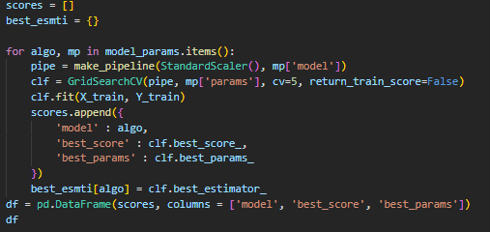

The Scores on the Training Dataset :

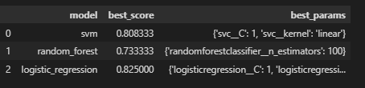

Logistic Regression with :

{'logisticregression__C': 1, 'logisticregression__solver': 'newton-cg'}

As parameters gave the best results.

1. **Testing the model**

The model is then tested with 30% of the dataset and the score came out to be

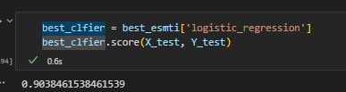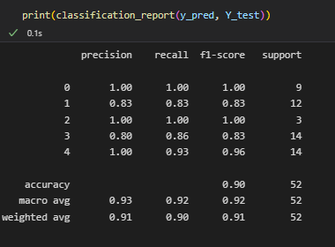

**WEEK 3 :**

Creating a simple Artificial Neural Network for classifying the Celebrities

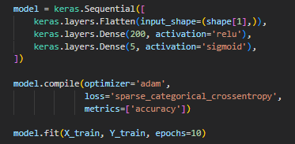

**WORK TO BE DONE**

1. The optimisation of the Artificial Neural Network and increasing the accuracy of the testing results.
2. Creating a Deep Learning Model and incorporating both the models in a Flask API.
3. Developing a fully functional Website that Portrays the Comparative Insights to the Machine Learning Model and the Deep Learning Model.
4. Deployment of the API.

OVERVIEW OF FLASK API Work :

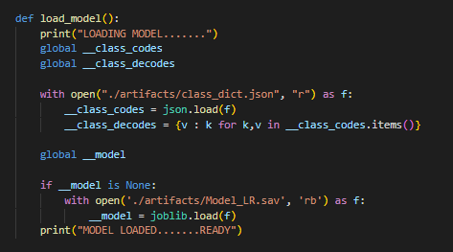

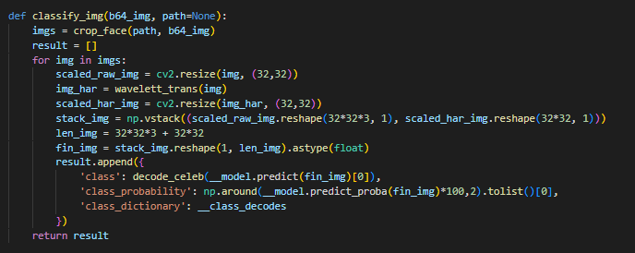

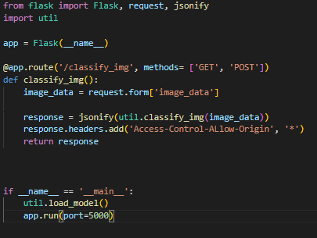

**FURTHER ENHANCEMENTS**

**BACKEND :**

* Using A Convolutional Neural Network for classification of images
* Improving the accuracy of the CNN model
* Parameter Optimisation and Increasing the hidden layers for best results.
* Incorporating the CNN model in the Flask API
* Recognition of Celebrity Images through CNN Model

**FRONTEND :**

* Improving the visual textures and templates
* Improving the API response

**DATASET :**

* Including personal images for recognition.
* Including some more celebrity images.
* Including the pictures of friends for recognition.
* Creating a Custom Dataset for Training.

**REFERENCE**

* YOUTUBE : Codebasics for Machine Learning
* YOUTUBE : Codebasics for FLASK API
* Pandas and Numpy Documentation
* YOUTUBE : Amaan for Wavelett Transformation
* OpenCV Documentation